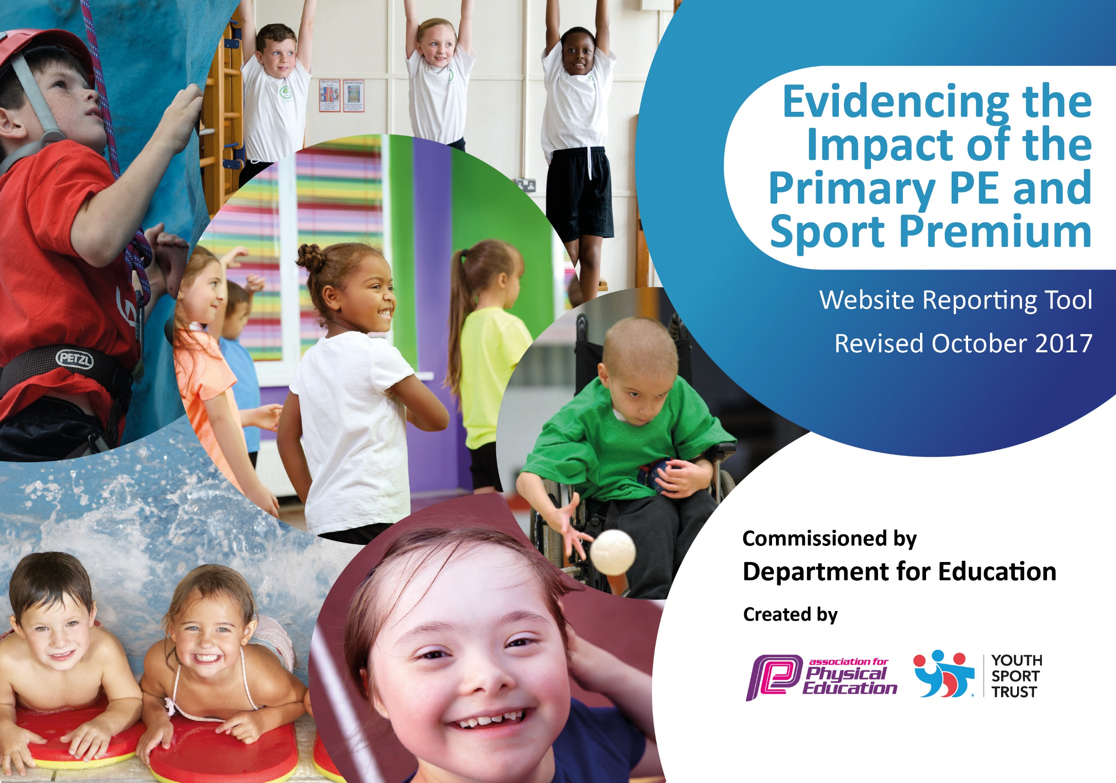

Schools must use the funding to make additional and sustainable improvements to the quality of PE and sport they offer. This means that you should use the Primary PE and Sport Premium to:

- develop or add to the PE and sport activities that your school already offers
- build capacity and capability within the school to ensure that improvements made now will benefit pupils joining the school in future years

Please visit gov.uk for the revised DfE guidance including the 5 key indicators across which schools should demonstrate an improvement. This document will help you to review your provision and to report your spend. DfE encourages schools to use this template as an effective way of meeting the reporting requirements of the Primary PE and Sport Premium.

We recommend you start by reflecting on the impact of current provision and reviewing the previous spend.
Under the Ofsted Schools Inspection Framework, inspectors will assess how effectively leaders use
the Primary PE and Sport Premium and measure its impact on outcomes for pupils, and how effectively governors hold them to account
for this.

Schools are required to publish details of how they spend this funding as well as on the impact it has on pupils’ PE
and sport participation and attainment.
We recommend regularly updating the table and
publishing it on your website as evidence
of your ongoing review into how you are using the money
to secure maximum, sustainable impact. To see an example of how to complete the table please click HERE.

Support for review and reflection - considering the 5 key indicators from DfE, what development needs are a priority for your setting and your students now and why? Use the space below to reflect on previous spend, identify current need and priorities for the future.

Key achievements to date: | Areas for further improvement and baseline evidence of need:
- Health for schools Gold Award  - Sports Award: Bronze level July 19  - Sports Competitions  - Extended Physical Activity sessions  - Inclusion through sports  - Healthy minds and bodies  - Confidence and academic achievements  - Focus daily activities  - Extended activities after school  - Sports Coach embedded  - Sports events- Sporting Visitors | Evidence based on health survey figures for Year 6 and Reception children 19/20. To achieve:  - Sports Quality Mark- Silver award.  - Raise profile of PE further  - CPD for teaching of PE  - Develop residence through PE  - Range of Physical Activity in extended provision  - Increase impact on academic achievements  - Identify further gifted and talented in sport  - Well Being Award

Meeting national curriculum requirements for swimming and water safety | Please complete all of the below:
What percentage of your Year 6 pupils could swim competently, confidently and proficiently over a distance of at least 25 metres when they left your primary school at the end of last academic year? | 95.6%
What percentage of your Year 6 pupils could use a range of strokes effectively [for example, front crawl, backstroke and breaststroke] when they left your primary school at the end of last academic year? | 65%
What percentage of your Year 6 pupils could perform safe self-rescue in different water-based situations when they left your primary school at the end of last academic year? | 26%
Schools can choose to use the Primary PE and Sport Premium to provide additional provision for swimming but this must be for activity over and above the national curriculum requirements. Have you used it in this way? | No

Action Plan and Budget Tracking
Capture your intended annual spend against the 5 key indicators. Clarify the success criteria and evidence of impact that you intend to measure to evaluate for students today and for the future.

Academic Year: 2018/19 | Total fund allocated: £ 17 490 | Date Updated: Autumn 2018
Key indicator 1: The engagement of all pupils in regular physical activity – Chief Medical Officer guidelines recommend that primary school children undertake at least 30 minutes of physical activity a day in school |  |  |  | Percentage of total allocation:
 |  |  |  | 91%
School focus with clarity on intended impact on pupils: | Actions to achieve: | Funding allocated: | Evidence and impact: | Sustainability and suggested next steps:
Inclusion through sport  Mile a day activities  Activities over lunch and break periods | Daily timetabled activities  Identified children taking part in further physical activities  Range of activities over break times  After School Activities | £14 490  £600 | Children engaging in physical activity outside of the PE curriculum | Continue to employ Sports Coach  Sports Quality Mark Gold award
Key indicator 2: The profile of PE and sport being raised across the school as a tool for whole school improvement |  |  |  | Percentage of total allocation:
 |  |  |  | 91%
School focus with clarity on intended impact on pupils: | Actions to achieve: | Funding allocated: | Evidence and impact: | Sustainability and suggested next steps:
Improve skill set for pupils across national curriculum PE subjects | SLA for sports purchased  CPD for Staff  Sports Coach to support  Audit of PE lessons  Audit of Curriculum  Lead PE teacher  Children identified for sports events and Gifted and talented in sports  Weekly Celebration and achievements | £14,490  £600 | PE lessons are further developed to meet NC and ensure breadth and depth of skills knowledge and understanding.  INCERTS used to evidence impact and achievement | Continue to employ sports coach  Further CPD for Staff  CoCoaching  Sports Quality Mark Gold award

Key indicator 3: Increased confidence, knowledge and skills of all staff in teaching PE and sport |  |  |  | Percentage of total allocation:
 |  |  |  | 94%
School focus with clarity on intended  impact on pupils: | Actions to achieve: | Funding  allocated: | Evidence and impact: | Sustainability and suggested  next steps:
To increase confidence knowledge skills of children | CPD for Staff  PE SLA  Sports Quality Mark Achieved. Silver Award.  Offering a range of activities | £500  £600  £800  £14 490 | INCERTS evidencing impact of CPD on lessons. Greater percentage of Children achieving ARE and above in PE. School Targets of 85%. | Continue with SLA and CPD  Sports Quality Mark Gold award  Continue to employ Sports Coach
Key indicator 4: Broader experience of a range of sports and activities offered to all pupils |  |  |  | Percentage of total allocation:
 |  |  |  | 85%
School focus with clarity on intended  impact on pupils: | Actions to achieve: | Funding  allocated: | Evidence and impact: | Sustainability and suggested  next steps:
Additional achievements through various sporting activities during and after school | Audit range of sports offered.  Increase range of sports offered  Timetable range of sports outside of the PE curriculum.  Raise the profile of sport and PE | £14490  £500 | Timetables in place for a variety of sporting and physical activities  Sports SLA impacting on activities  Sports Quality Mark Achieved. Silver Level | Continue with sports coach. Further audit of sporting and physical activities and children taking part.  Continue to raise the profile of sport and physical activities.  Sports Quality Mark Silver level
Key indicator 5: Increased participation in competitive sport |  |  |  | Percentage of total allocation:
 |  |  |  | 91%
School focus with clarity on intended  impact on pupils: | Actions to achieve: | Funding  allocated: | Evidence and impact: | Sustainability and suggested  next steps:
A increased percentage of children participating in sporting competitions | Sports Quality Mark silver level achieved  PE SLA purchased  School Teams set up  Profile raised with Parents. S | £14 490  £600 | Sport Quality Mark Silver Level Achieved  Profile of PE and physical activity increased | Continue to employ sport coach  Sports Quality Mark Gold Level achieved

