**Olympics Quiz 2012**

1. In what year was the first Modern Olympic Games held?
2. Where was it held?
3. How many events will there be at the London 2012 Olympic Games?
4. How many nations will take part in the Olympics?
5. And in the Paralympics?
6. Including 2012, how many times has London hosted the Olympics?
7. Which sport will be played at Lord’s Cricket Ground this year?
8. Can you name two sports that will be played at The O2?
9. What are the names of the London 2012 Olympic mascots?
10. How many events are in the decathlon?
11. Can you name all of them?
12. During which two dates will the London 2012 Olympics take place?
13. And the Paralympics?
14. The logo for the Olympics is a set of 5 linked rings, what do they represent?
15. And what colours are the rings?
16. Why were those colours chosen?
17. Which nation does this flag represent?

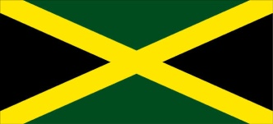

1. Which nation does this flag represent?

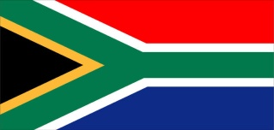

1. Which nation does this flag represent?

C:\Users\Alex\AppData\Local\Microsoft\Windows\Temporary Internet Files\Content.IE5\XNB9S3XC\MC900025657[1].wmf

MAXIMUM 30 POINTS

**Olympics Quiz 2012 Answers**

1. 1896 1point
2. Athens 1 point
3. 300 1 point
4. 205 1 point
5. 147 1 point
6. 3 Hosted in 1908, 1948 and 2012 1 point
7. Archery 1 point
8. Any of these answers: Artistic gymnastics, Trampoline, Basketball, Wheelchair basketball, Badminton, Rhythmic gymnastics maximum 2 points
9. A point for each Wenlock and Mandeville maximum 2 points
10. 10 1 point
11. A point for each correct answer: 100m, long jump, shot put, high jump, 400m, 100m hurdles, discus, pole vault, javelin and 1500m maximum 10 points
12. 27th July – 12th August 1 point
13. 29th August – 9th September 1 point
14. The five original nations that took part (Africa, America, Asia, Australia, Europe) 1 point
15. One point for correct colours: Red, yellow, green, black, blue 1 point
16. At least one of those colours are found on the flag of every nation that participates in the Olympics 1 point
17. Jamaica 1 point
18. South Africa 1 point
19. Russia 1 point

Maximum 30 points

Created by Kim Miree